

Harbor Electronic Publishing

84 Mount Misery Dr • Sag Harbor NY 11963 • 631 725 9513

*HEPDigital.com* • *Sales@HEPdigital.com*

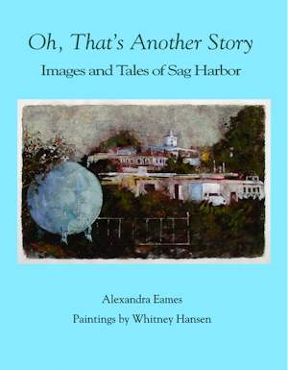For immediate release: new publication

*Oh, That’s Another Story:*

*Images and Tales of Sag Harbor.*

Alexandra Eames

illustrated by Whitney Hansen

Long-time Sag Harborites writer Alexandra Eames and painter Whitney Hansen have collaborated on this eloquent portrait in words and images of the 300-year-old village of Sag Harbor, NY.

From its beginnings as a leading whaling port in the nineteenth century Sag Harbor developed into an industrial center in the twentieth century. Today, the village is a center of art and literary culture for the East End of Long Island—and a major tourist destination.

Sag Harbor offers an environment that is diverse, respectful of tradition, and at the same time tolerant of strangers and new ideas.

Eames’s insightful interviews with dozens of old-timers combine with Hansen’s evocative paintings of the varied Sag Harbor landscape to present a unique portrait of this remarkable village.

With 75 full-color reproductions of Whitney Hansen's paintings.

130 pp, 75 illustrations, paperback: $40

Publication Date July 11

More info: James Monaco [jim@peconic.org](mailto:jim@peconic.org)

Graphics and samples: HEPdigital.com/Press.html